Automation User Guide

The purpose of this document is to serve as a quick reference guide to understand the work done on automation.

Application URL: https://sdetapplication.recruiterbox.com/
Browser Automated: Chrome
Pre-requisites: System should have the following:
- Windows 10 OS machine with latest Chrome browser installed
- Python, PyTest, and Selenium library installed
- Chrome driver to be placed in the location (D://Python/chromedriver.exe)
- To run the scripts on additional browser, update conftest.py file with additional parameter and details
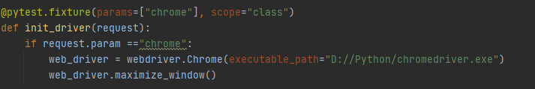

Details
Framework Used | Selenium with PyTest
Programming Language | Python
Design Principle | Page Object Model
Scenario Automated | Applying “FullStack Engineer” job position on recruiterbox

Design principle used: Page Object Model (POM)

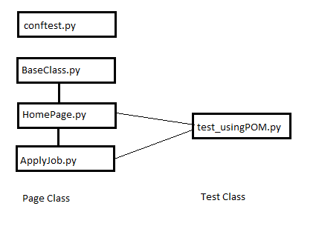

Page Class | Methods
BaseClass | def do_click(self, by_locator):  def do_send_keys(self, by_locator, text):  def do_get_text(self, by_locator):
HomePage(BaseClass) | def do_searchposition(self, search_textbox, searchtxt):  def do_selectposition(self):
ApplyJob(BaseClass) | def do_clickApply(self):  def do_clickSubmit(self):  def do_getconfirmtxt(self):

Scenario Automated: Search and Apply for FullStack Engineer job position on Recruiterbox site
The above scenario has been automated using two approaches:
- Using Stand-alone script -> test_e2e_no_POM.py

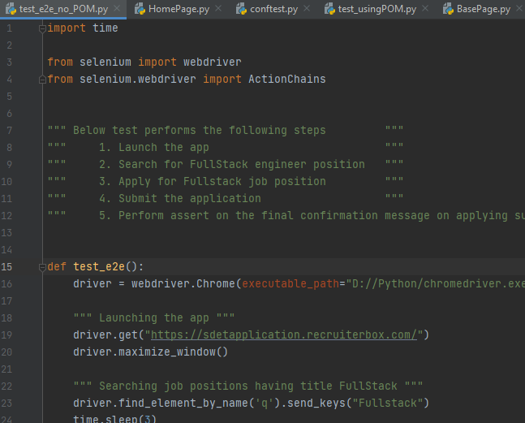
- Using POM design principle
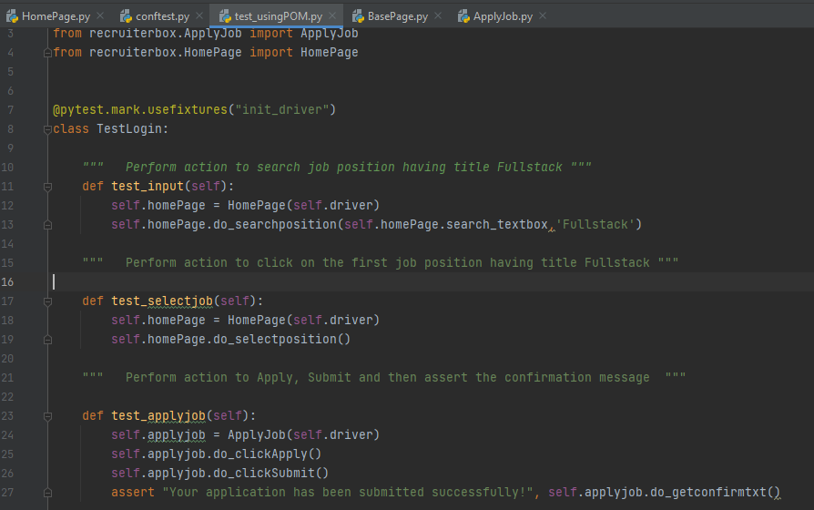

Test Result Output:
- Stand-alone script:

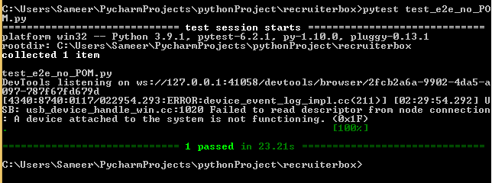

- POM script:
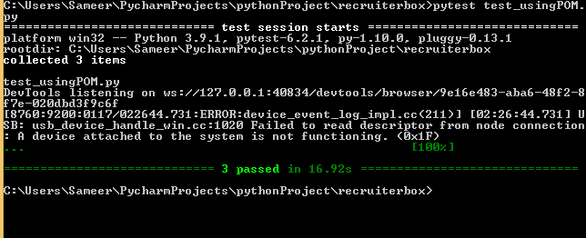

Challenges Faced:
- Search button was not getting recognized using the Find Elements method so had to use ActionsChain class to overcome this issue.

